Array Index Out Of Bounds Exception

Apart from ***AirthmeticException***that we have handled in our previous posts, we have many other Run Time exceptions. To start with, I will explain '***ArrayIndexOutOfBoundsException***' in this post.  
  
  
**ArrayIndexOutOfBoundsException**- Each array consists of a concrete number of elements. For example int a[] = new int[2] contains two fixed number of elements i.e. a[0] & a[1]. But when you are trying to assign a value to a non existing element a[5] , or when you are trying to provide negative index value while assigning a value say a[-1], Java will throw ArrayIndexOutOfBoundsException.  
  
Lets implement this on Eclipse IDE -  
  
1. Launch Eclipse IDE, create a new Java Class file 'ArrayIndexOutOfBoundsExceptionDemo.java' with main( ) method in the existing project 'Project 46' as shown below -

[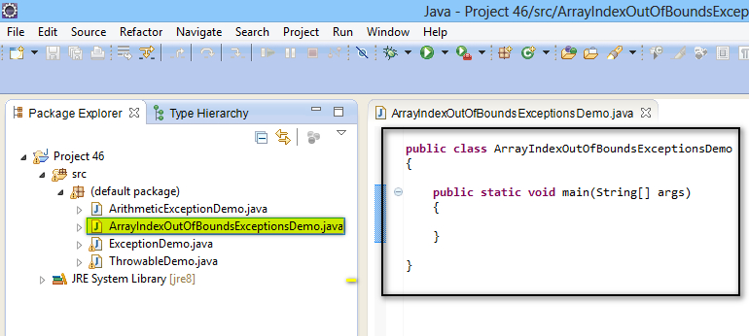](https://3.bp.blogspot.com/-0DPWgtqL7FQ/U-slY0N8F6I/AAAAAAAAbug/NDplf5QMW6g/s1600/1.jpg)

2. Create an integer array with length 2 as shown below -

[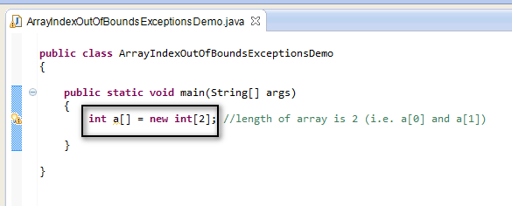](https://1.bp.blogspot.com/-g1tQJXfEj-4/U-s2MGkmajI/AAAAAAAAbv0/nEdayp3aYI8/s1600/2.jpg)

3. Now try to assign a value to a non-existing array element whose index is out of the given range as shown below -

[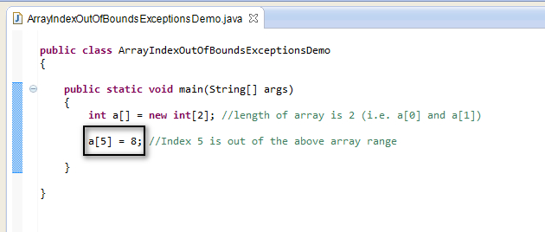](https://4.bp.blogspot.com/-lBT2VsAxVtU/U-s2mL4JKmI/AAAAAAAAbv8/Yz0g7JCgOUQ/s1600/3.jpg)

4. Save and Run the 'ArrayIndexOutOfBoundsExceptionDemo.java' class file and observe that the program got terminated by printing the exception details in the Eclipse IDE -> Console as output -

[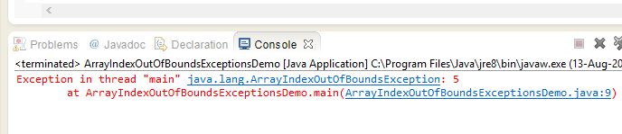](https://2.bp.blogspot.com/-17dQn3liSXU/U-s2wBmTKxI/AAAAAAAAbwE/KMPg72lkNMQ/s1600/4.jpg)

5.  Now handle the occurred exception using 'ArrayIndexOutOfBoundsException' Class in try{ } catch{ } blocks as shown below -

[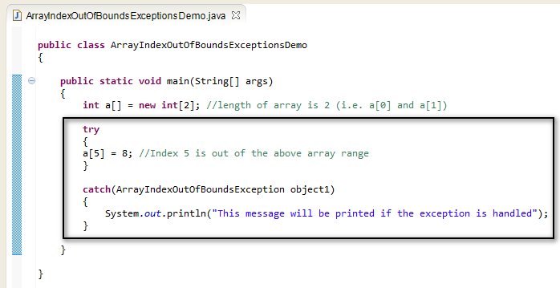](https://2.bp.blogspot.com/-p1rOYexjwS0/U-s3Kkzdb-I/AAAAAAAAbwM/NIcjazKt9Hs/s1600/5.jpg)

6. Save and Run the  'ArrayIndexOutOfBoundsExceptionDemo.java' class file again and observe that the exception is handled using the ArrayIndexOutOfBoundsException Class in catch{ } block by giving the following output as shown below -

[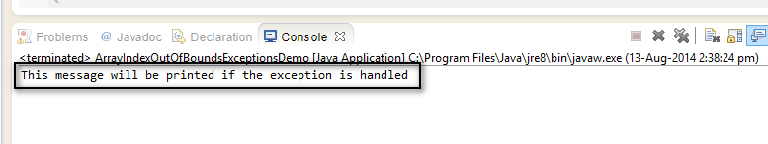](https://3.bp.blogspot.com/-8LcA3zb4LTg/U-srHmQgDgI/AAAAAAAAbvU/yoFl3-JV4aE/s1600/6.jpg)

7. Now change the statement in the try from from a[5] to a[-1] to find out whether the exception is also occurring for the negative index of array as shown below -

[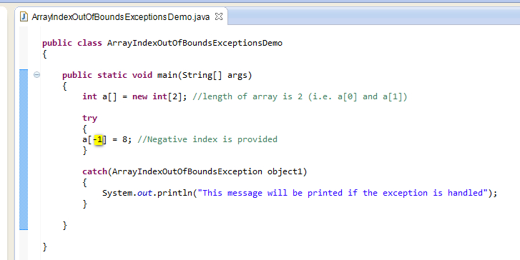](https://2.bp.blogspot.com/---eypTeAZO8/U-s3gERcdGI/AAAAAAAAbwU/jyNHSRUGur4/s1600/7.jpg)

8. Save and Run the  'ArrayIndexOutOfBoundsExceptionDemo.java' class file again and observe that the exception is handled using the ArrayIndexOutOfBoundsException Class in catch{ } block by giving the following output as shown below -

[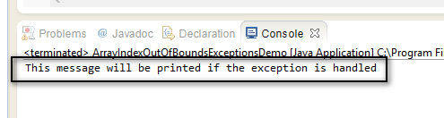](https://4.bp.blogspot.com/-Ges8LA1ISk4/U-sru-Vgo_I/AAAAAAAAbvk/4fu54EYnwOo/s1600/8.jpg)

Since the statement in the above screen is printed in the output, the statement in the try{ } block i.e. array element having negative index value has thrown the 'ArrayIndexOutOfBoundsException' exception.  
  
Hence we have used ***ArrayIndexOutOfBoundsException***Class for handling the array index is out-of -bounds exception.